SUNRISE SENIOR LIVING
proudly presents
CARS & COFFEE
with classic cars provided by the
ANTIQUE MOTORING CLUB OF MONMOUTH COUNTY
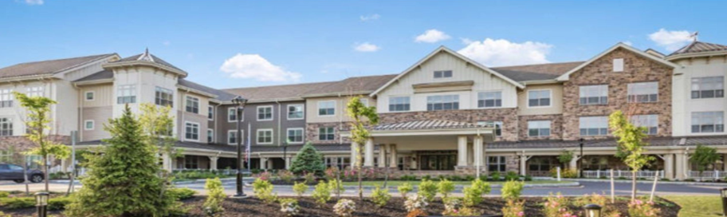

SUNDAY, JUNE 9, 2024
10:00 AM – 12:00 NOON
766 BROAD STREET, SHREWSBURY

Limited Entrants

A DISPLAY OF CLASSIC CARS FOR THE RESIDENTS’ ENJOYMENT
PLEASE CONTACT DAN LADEN @ 732-615-8587 TO BRING YOUR CLASSIC CAR
REFRESHMENTS & RESTROOMS ON SITE

Club members are invited to participate by Sunrise Senior Living in Shrewsbury. The “Attendee” assumes all responsibility for all related risks, dangers, and hazards, and agrees that AMCOMC is not responsible for any injury, damage, or cost caused by or to “Attendee” with respect to any person or property. All property losses, including damage to private property, vehicles, and/or personal injuries are the sole responsibility of “Attendee”. Submissions of claims for insurance reimbursement must be submitted by “Attendee” under their own personal or vehicular policy(ies). Any vehicle utilized is required to be insured and registered.

